**Assignment -3**

Digital Marketing

|  |  |
| --- | --- |
| Student Name | Vigneshwarakarathick M |
| Student Register Number | 953720106033 |
| College Name | AAA College of Engineering and Technology |

**QUESTION:**

**SOCIAL MEDIA ADVERTISEMENT POSTER USING CANVA:**

**Poster link:**

[**https://www.canva.com/design/DAFZgQrsvSI/1aMlujBXLdzDqMVov_zSdA/edit?utm_content=DAFZgQrsvSI&utm_campaign=designshare&utm_medium=link2&utm_source=sharebutton**](https://www.canva.com/design/DAFZgQrsvSI/1aMlujBXLdzDqMVov_zSdA/edit?utm_content=DAFZgQrsvSI&utm_campaign=designshare&utm_medium=link2&utm_source=sharebutton)

**Poster Title: Naveen Coffee Shop**

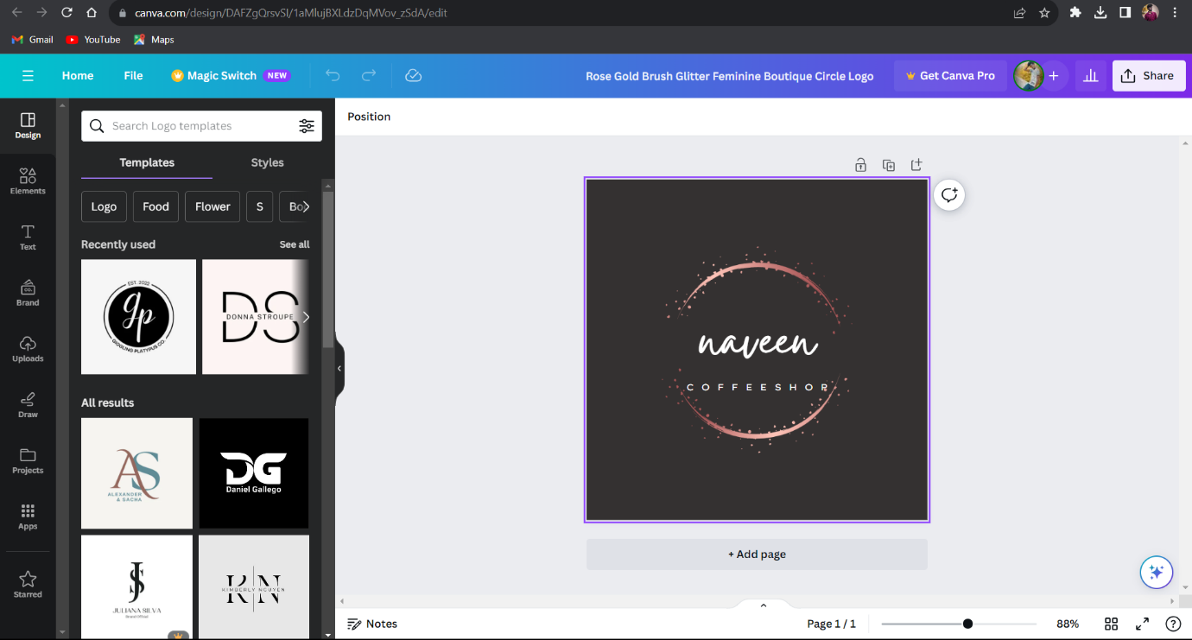

**Poster:**

